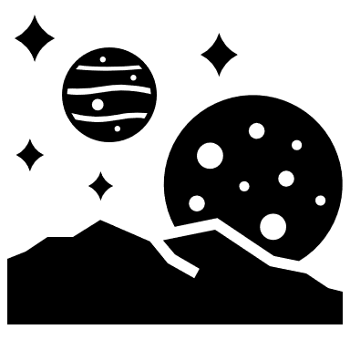
Let us celebrate our Space topic and exercise our imaginations this week with some Art and Design.
Planets of our Solar System
Can you create a representation of the planets of our solar system? It could be a 2D drawing or a painting; a 2D or 3D collage; 3D models from things you have at home or perhaps you could use your computer skills to create your planets.
What you have at home will vary so just use what you have and make it fun. We will give you some suggestions but feel free to use any ideas of your own. If you can, photograph your finished art and send it in to us however you can.
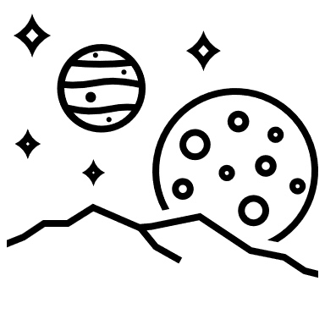
First, you will need to research the planets in our Solar System, the Milky Way. How many are there? What are they called? What does each planet look like? What size are they? Where are they in relation to our Sun? Why do they have different atmospheres?
Next, think about what materials you have that could help you represent a planet/the planets in space. Could you…
- Draw or paint a picture of all the planets or maybe just your favourite one.
- Do some 3D modelling – Papier Mache is good but so is play dough, folded paper, plies of clothes/towels, wool, fabric or pebbles. It does not need to be permanent – think of Andy Goldsworthy.
- Get in the kitchen – how about biscuits in different sizes for each of the planets? Just take a snapshot before you eat them!
- Photograph yourself dressed as each of the planets.
- Use computer aided design to create the solar system or individual planets?
These are just suggestions. Do as many or as few as you wish. If you have any ideas of your own that will also be excellent.
Here are some links and examples to help you get inspired.
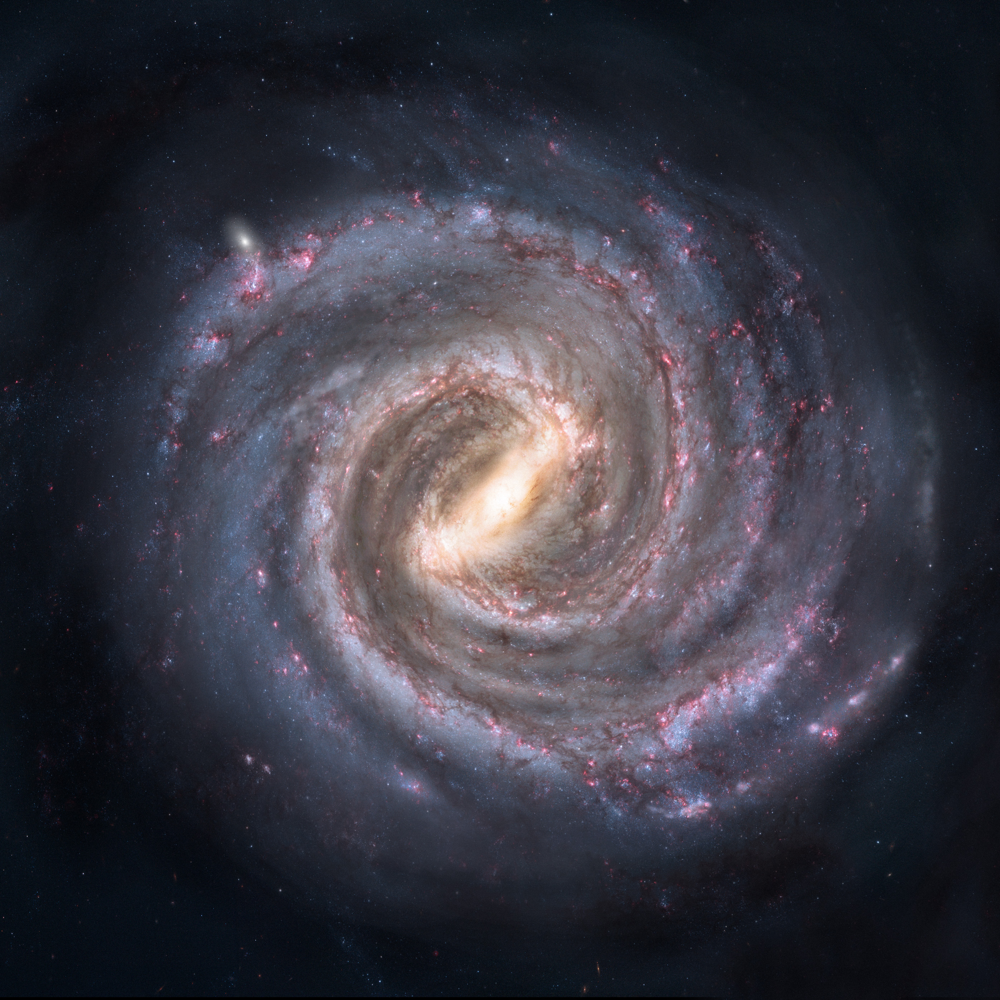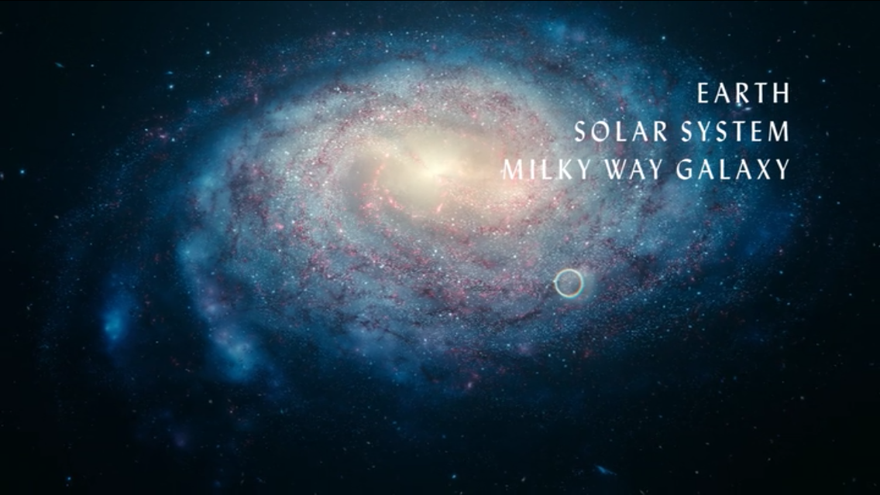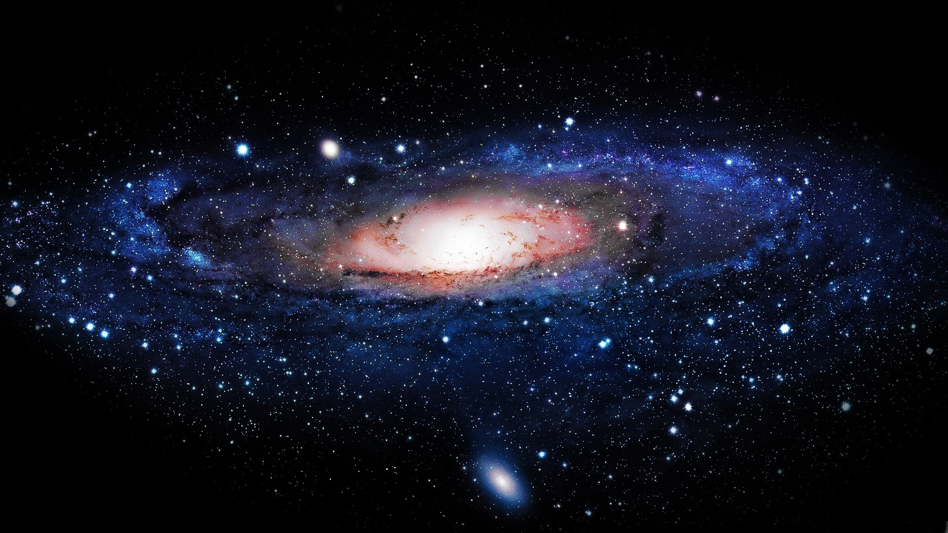
The Milky Way
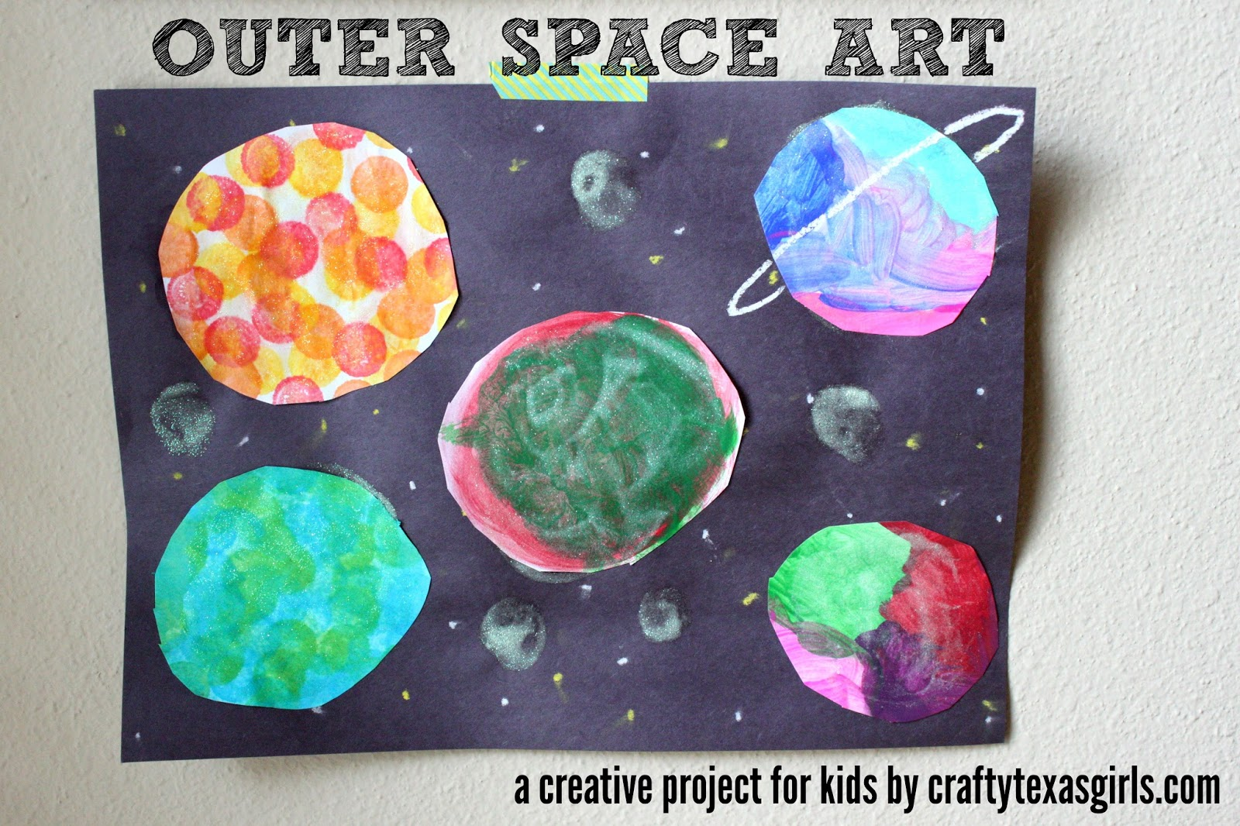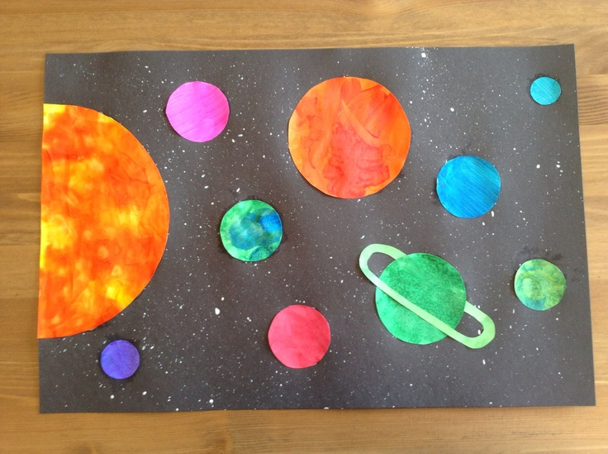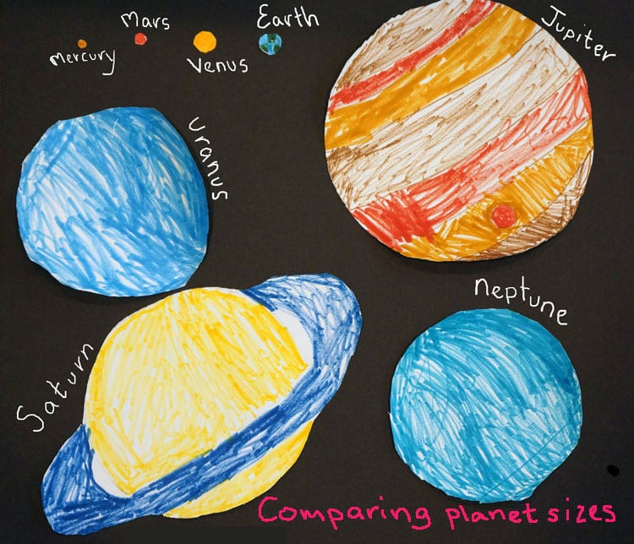
Planet baking:
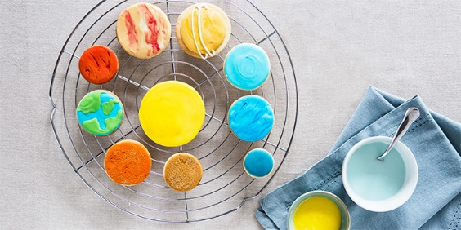
https://www.bbcgoodfood.com/howto/guide/amazing-half-term-space-projects-kids
https://www.bbcgoodfood.com/recipes/basic-biscuit-dough
http://allrecipes.co.uk/recipe/33214/simple-biscuits-without-eggs.aspx
Drawing tutorials:
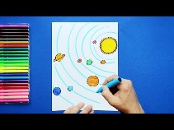
https://www.youtube.com/watch?v=wAJg6aKqLBk
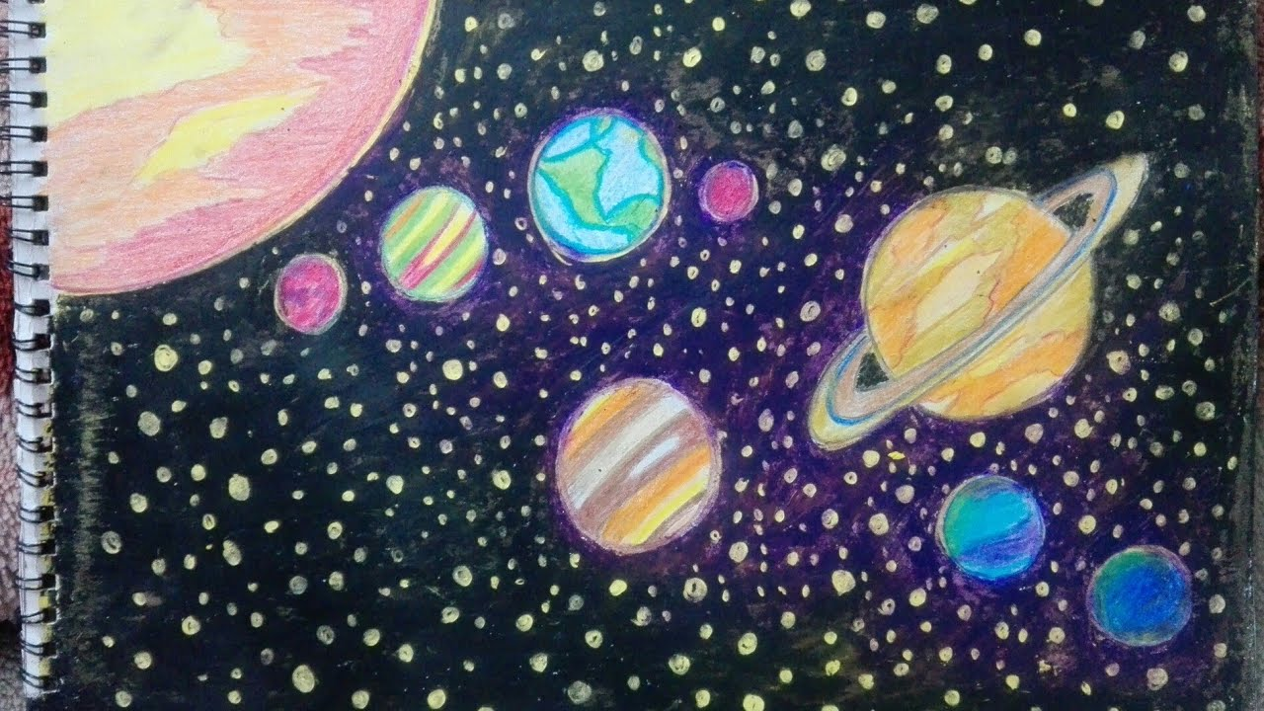 https://www.youtube.com/watch?v=sESvlZa514Q
How to Make Paper Mache Planets - 3D Solar System Crafts for Kids
https://www.youtube.com/watch?v=M7iokGsaYus
Play dough recipes:
https://www.instructables.com/id/How-to-Make-Playdough-Play-doh/
https://www.bbcgoodfood.com/howto/guide/playdough-recipe
Finally, remember to photograph your artwork so you can send it to us. We love seeing how creative you all are and having the opportunity to show off how fabulous you all are.

