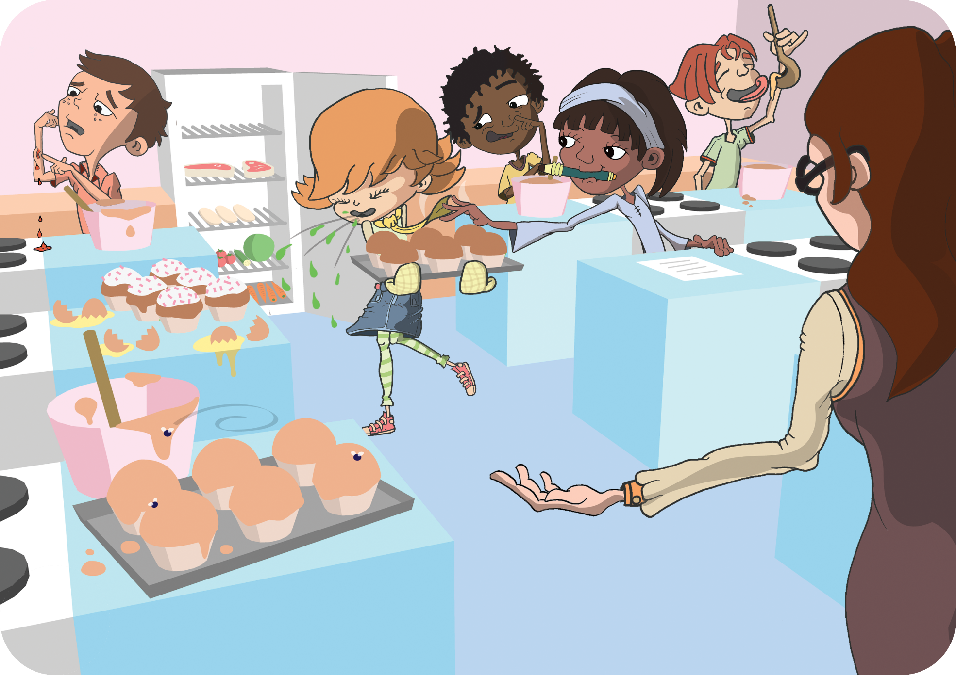C:\Documents and Settings\Sandy\Desktop\eBug\Logo\Final Logo\Final Logo.emf



**SW 2**

**FOOD**

**Can you circle 9 things that the students in this cookery class should not be doing and why?**